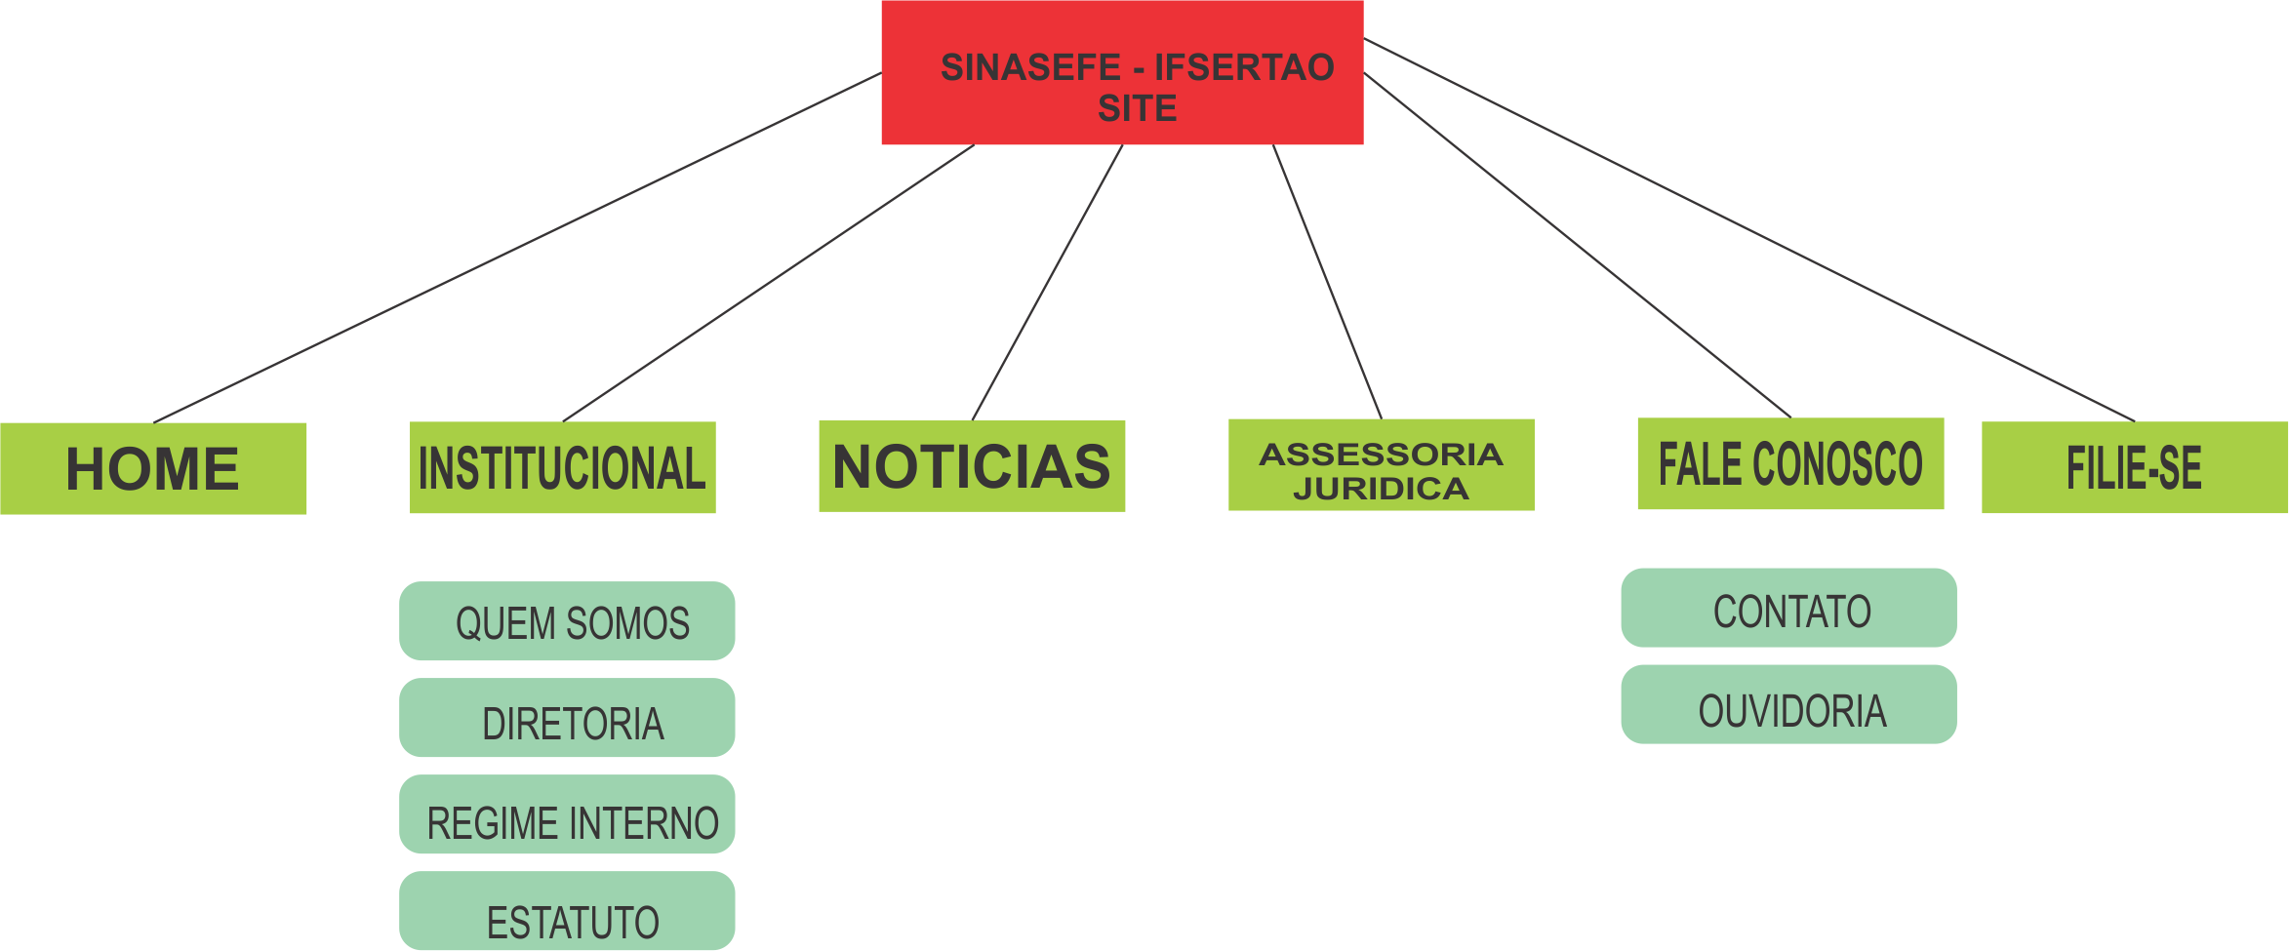

1. No Index conter slider informativo E links importantes